Projectile Motion: Angry Birds

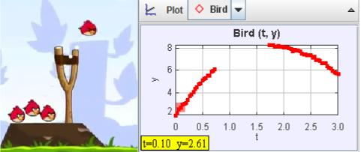

In the game Angry Birds, birds are shot from a slingshot. Does their motion follow the principles of projectile motion? We can use video analysis to answer this question.
When we do video analysis, we chose an item in the video to use as a reference to determine distances (how many pixels equals 1 meter, for example). In the case of Angry Birds, instead of scaling the video with a known object on the screen, we can scale the video by the acceleration due to gravity, assuming the Angry Bird world is the Earth.

Begin by downloading the following files:
- angry_bird_short.mov
- angry_bird_projectile.trk

The “trk” file is a partially marked Tracker file and if you double click it (and Tracker is installed), it should launch a tab in Tracker (it will likely ask you where the video file is and you will have to point to where you downloaded the mov file). Play the video and notice that the “camera” moves to follow the bird and that the window changes size.

In order to track the bird, we will need a fixed origin (the slingshot) and since the origin goes off screen, we need an offset point (the distance from the slingshot to a blade of grass that shows up for most of the trajectory of the bird).

We also need a set length since the movie zooms in and out. It turns out that the height to the fork of the slingshot is the same as the height of the pedestal the pig sits on. We will establish this height as “1” in “trk” file. Now, even as the image zooms and pans, the length of the pig’s pedestal is always “1” and the location of the origin is set. DO NOT adjust the “Coordinate Offset” or the “Calibration Stick” or the data will no longer account for the movement of the camera or the zooming in and out on the screen.

The“trk” file already has the position of the angry bird marked. The track of the marked points is not a parabola on the video. Why not?

The track is not a parabola because the window moves which causes the axis to move.

The plots of x vs. t and y vs. t match more closely with what you might expect for projectile motion. Sketch the plot of x vs. t below: 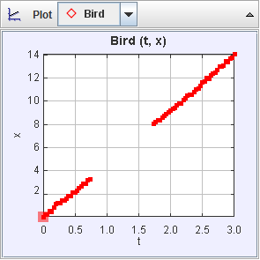

Explain why some points are missing:

Some points are missing because the bird goes above the window which means there is nothing to be measured.

Explain why the plot is a straight line:

The plot is a straight line because it is measuring horizontal motion which has no forces acting on it.

Now, sketch the y-position data as a function of time (click on the vertical axis label “x” and change it to “y”).

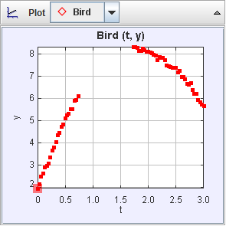
Why is it parabolic (or would be if there weren’t missing data)?

The graph is parabolic because it is measuring vertical distance which has gravity acting on it.

Now, we are going to fit the data of the position versus time graph. Right-click on a plot (graph) you want to fit (y versus t for one of the masses) and choose Analzye:

A new window opens up with the title Data Tool. Click the Fit check-box and then, because the graph is parabolic, pick Fit Name -> Parabola:

Record the following:

a | -1.882
b | 6.833
c | 1.993

These coefficients correspond to the equation of the form:
y = at² + bt + c

Now, when two other students, Pat and Jordan, previously fit their data, they got the following (this is not the data you will get, it is simply an example):

a | -4.8
b | 3.0
c | 1.2

Taking the above information and transforming it to the book’s notation, their equation of motion would be the following:

y = 1.2 + 3.0t – 4.8t²

For the previous example with Pat and Jordan’s data, (assuming that the ball has just left the hand at t = 0) what is the equation of the velocity in the y-direction (differentiate the equation of displacement):

y= 3-9.6t

What is the vertical velocity right after the ball left the hand of the person throwing in this example?

V_{i}= 3

Q1. Pat and Jordan’s measured initial vertical velocity is
A. 1.2
B. 3.0
C. -4.8
D. -9.6
E. -9.8
F. none of the above

For this example, what is the equation for the acceleration for Pat and Jordan’s data (second derivative of position function)?

A= -9.6

Q2. Pat and Jordan’s measured acceleration is
A. 1.2
B. 3.0
C. -4.8
D. -9.6
E. -9.8
F. none of the above

Now, back to your data.

What is your equation of motion?

y = -1.882t²+6.833t+1.993

Differentiating this, what is your equation for the velocity as a function of time?

v_{y} = -3.764t+6.833
What is the “initial” velocity in the y-direction (velocity leaving the sling shot)?

v_{0y} = 6.833

What is the acceleration (from your data)?

a_{y} = -3.764

You should not get a value of -9.8 or anything close to that because your acceleration is in units of pig pedestal/second². Why is that your unit instead of m/s²??

Pig pedestal/second² is the unit because that is what we established as “1” before we did the measurements.

If we assume the acceleration due to gravity is -9.8 m/s², what is the conversion for pig pedestal units to meters? For example, if Pat and Jordan found (with different data from above):

a_{y} = __-3.5 pig pedestals/s²__________

Then they know that
3.5 pig pedestals= 9.8 m or
1 pig pedestal = 2.8 m

What is your conversion between pig pedestals and meters?

1 pig pedestal = 2.6 m

Your “measuring tape” is calibrated to pig pedestal units. Click on your measuring tape (Tape A) to measure the following (click on an end to adjust the length):

How many pig pedestal units tall is the sling shot?

1.789 pig pedestal
How many meters is that?
4.6m
How many pig pedestal units is the angry bird?
.38 pig pedestals

How many meters tall is the angry bird?
.988m

Is that a big or small bird? Explain.

The bird is a big bird. Most birds from top to bottom, not head to tail or wing to wing, are far less than .3m so .988 is a huge bird.

From your tracker data, what is the initial
y-velocity of the angry bird in m/s (instead of pig pedestal units/s):

v_{oy} = 7.6m/s

Now, go back to the graph of x versus time and fit the x-position data to a line (instead of a parabola):

x-position equation:

x = _____________________

What is the initial velocity in the x-direction?

v_{0x} = __________________pig pedestals/s

What then is the initial speed of the launch from the sling shot (magnitude of the initial velocity vector)?

a | 4.637
b | -0.067

(from x = a*t + b)

x-position equation:

x = 4.637t+-0.067

What is the initial velocity in the x-direction?

v_{0x} = 4.637pig pedestals/s
and in meters/s:

v_{0x} = 12.056 m/s

What then is the initial speed of the launch from the slingshot (magnitude of the initial velocity vector)?

21.470 m/s

Based on this analysis, what can you conclude about the motion of the birds in Angry Birds?

The Angry Birds have very large birds that travel at very high speeds (for a bird).

Inspired by Rhett Allain’s DotPhysics blog for Wired Magazine: “The Physics of Angry Birds,” Oct 8, 2010. http://www.wired.com/wiredscience/2010/10/physics-of-angry-birds/ and by Frank Nochese’s Action-Reaction blog, “Angry Birds in the Classroom,” http://fnoschese.wordpress.com/2011/06/16/angry-birds-in-the-physics-classroom/ (accessed Nov 21, 2011).

